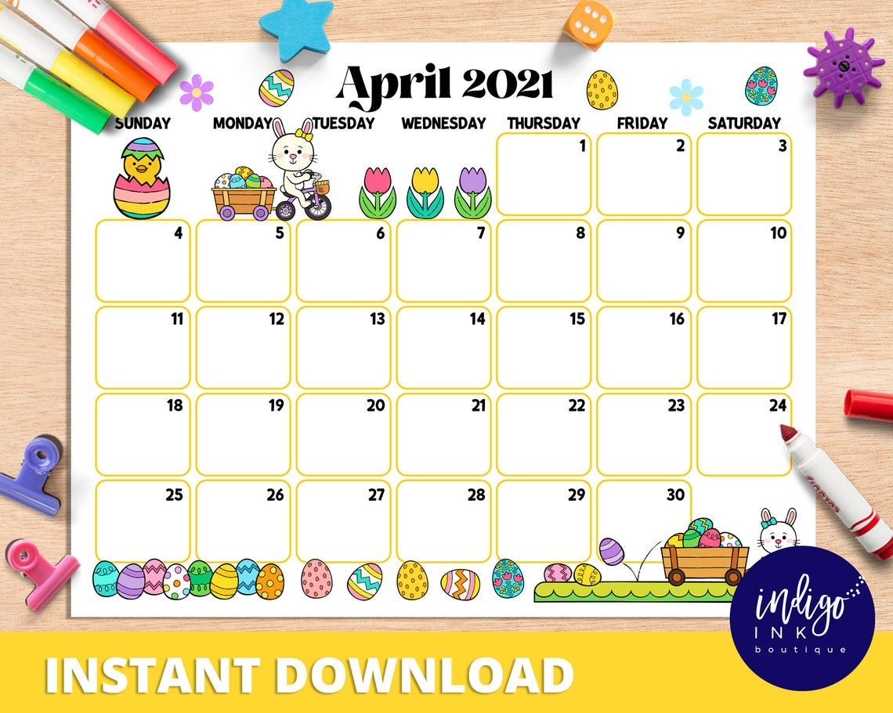

Academic Support 4-6PM

Bridgeprep Academy of Orange

Ice Cream $1 No Uniform $1 **Kindergarden -Egg Hunt**



3-4PM Bulldogs Getting Ready for Testing…

**We’ve GOT this!**

**Ice Cream $1 No Uniform $1**

**Academic Support 4-6PM**

**Academic Support 4-6PM**

**Best Attendance of the Week** (Pizza Celebration)



**NO EARLY DISMISSAL**

**Academic Support 4-6PM**





**BIG Red Bus** (Donate Blood) 10-3pm  **Academic Support 4-6PM**

**Early Dismissal**

**Pizza Sale $2 No Uniform $1**





**Early Dismissal**

**Academic Support 4-6PM**

**Academic Support 4-6PM**

**Ice Cream $1** **No Uniform $1**

**Early Dismissal**

**Academic Support 4-6PM**



**Pizza Sale $2** **No Uniform $1**

**Denim Day (Jeans Day)**

**Academic Support 4-6PM**



